AWS S3

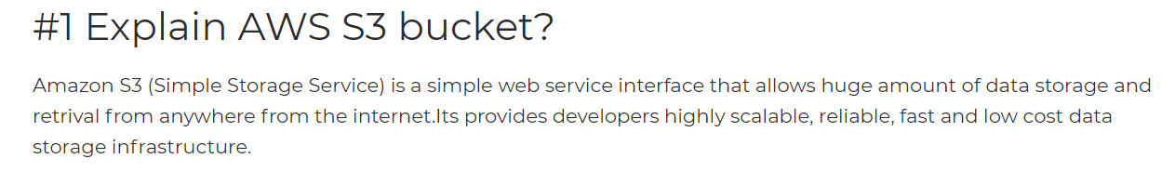

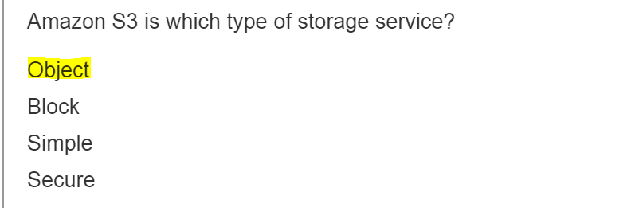

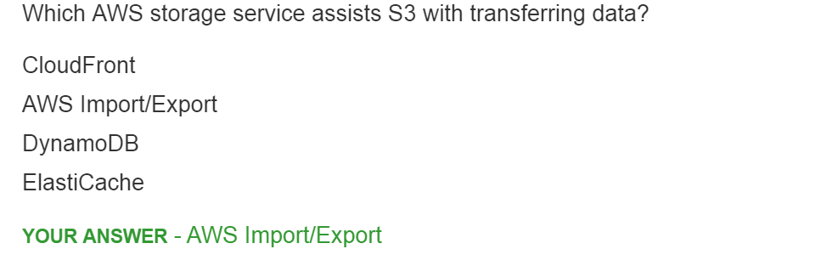

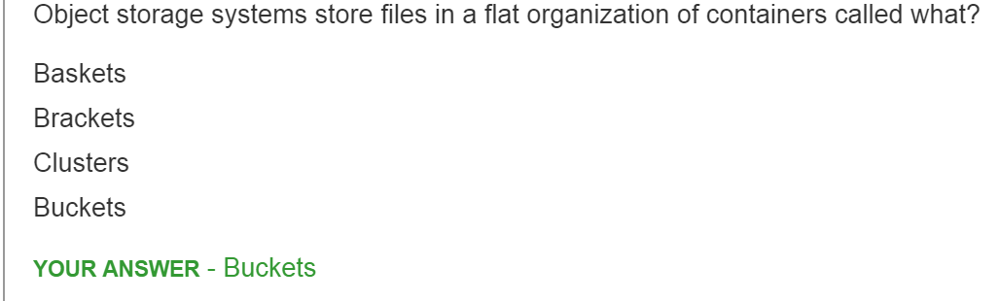

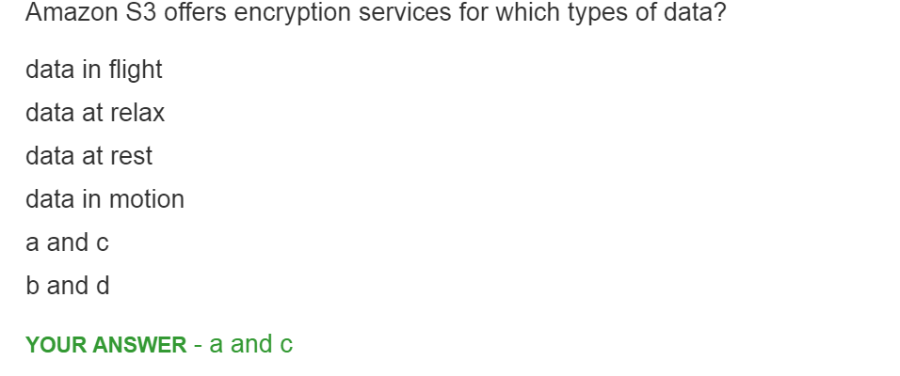

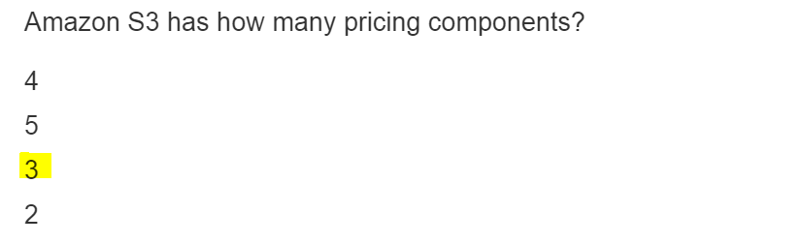

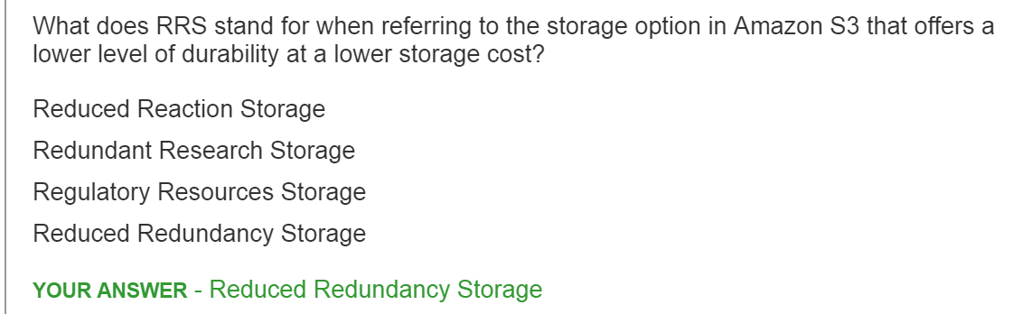

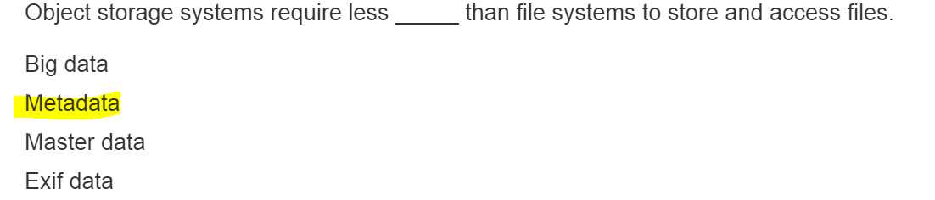

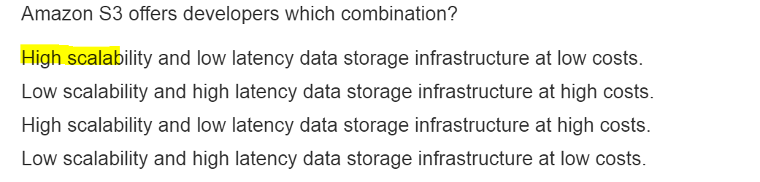

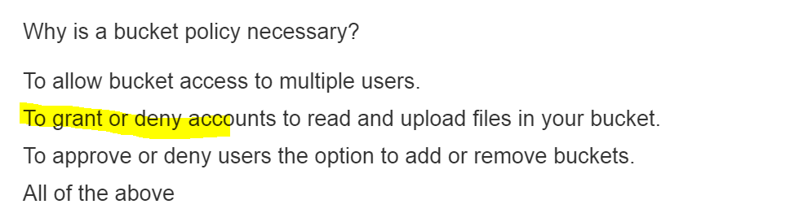

1. **S3 Standard storage class stores data across _____ availability zones.**

* 4
* 2
* 3
* 1

2. **S3 Standard Infrequent Access (IA) offers ____ availability.**

* 99.9
* 99.5
* 99.99
* 99.999999999

**3. S3 offers following storage classes (Choose all that apply).**

* One Zone – Infrequent Access
* Standard Storage
* Backup Storage
* Infrequent Access

4**. Jimmy is well known photographer in California. He is approached by many prospects for various assignments. To enable global access, Jimmy has uploaded his portfolio in S3 buckets. He has categorized his photos in different folders of S3 bucket. Jimmy realized that to impress the prospects he must share his content with them but not for indefinite time. One of his friend recommended ____.**

* S3 provides static website hosting feature and doesn’t perform any authentication of users accessing the content.
* Develop an application which hides S3 URL and ask prospects to download the application.
* Create Query Parameter based authentication to enable limited time access and expiring links.
* S3 can perform authentication using Query parameters but doesn’t support limited time feature.

5**. Felicia generates lot of content on regular basis and uses S3 to store it. She requires data that has been uploaded in last 30 days. Data prior to the 30 days should be stored for legal auditing and it happens once in a year. What approach you will recommend to keep the billing cost to minimum?**

* Felicia must manually maintain track of data uploaded and move the data herself.
* Use Object Lifecycle Management feature (per bucket) to move data between different storage classes based on the duration.
* Use Object Lifecycle Management feature (per object) to move data between different storage classes based on the duration.

**6. XYZ limited company is looking for utilizing S3 as static website hosting. Based on the pilot program they realized that S3 can scale very well under load and looks to be a viable option for their needs. One of the architect recommended that before uploading the web pages on S3, they should carefully choose the region for bucket. The architect says that the prices for each region vary and hence there will be considerable difference in billing.**

* S3 Prices do vary by region. AWS charges less where the cost is less.
* S3 Prices do not vary by region and hence XYZ should not bother about selecting a region.
* Charges for S3 standard storage remain same across regions, but if you enable static website, the charges will differ.

7. **You have stored more than 3000 objects in one bucket. The objects consists of PNG, JPEG, Excel sheets and word documents. There is need to transform all the word documents to PDF. You are looking for an efficient option to download only word documents.**

* Keep a separate database table and make sure it is updated with metadata of the objects you have uploaded.
* Manually select the files from S3 bucket and download them one by one.
* S3 is not suitable for such requirement. Better upload the objects to database directly and use native SQL features of the database.
* S3 SELECT can be used to fire SQL like query to select only objects matching to criteria.

8**. Global Medicine Pvt. Ltd. stores all its billing invoices in S3 buckets. Amanda realised that one of her colleague has recently deleted an invoice stored in the bucket. Amanda is worried about the event and contacted Greg (Cloud Architect) to recover the data. Greg seems to be very confident that the data is not lost and can be easily recovered.**

* Greg has already enabled versioning on S3 bucket and he knows that the file has not been removed but only delete marker has been placed.
* Data stored in S3 is never lost.
* Greg feels AWS might have maintained the backup of S3 in their own systems. He can drop a request to AWS support to recover data.
* Greg has false confidence in S3. The data is permanently deleted.

9. **Genova Research Lab stores it’s research data into S3 buckets. As a security measure, they have strict policy to enable only Private access and no public access on buckets. They have recently setup a VPC for one of its mission critical system. While developing the system, the engineers realised that they do require access to S3 buckets from VPC. What option you will suggest?**

* Create VPC Endpoint to S3 bucket and access the data.
* Data stored in S3 bucket (whether private/public) cannot be accessed from VPC. You must setup NAT gateway to access S3.
* Private access forbids VPC from accessing content from S3 buket.
* S3 data should be moved to DynamoDB and systems in VPC should use DynamoDB API to access the data.

10. **An Individual object size in Amazon S3 bucket can range between _____ to _____.**

* 0 to 5 GB
* 0 to 100 MB
* 0 to 5 TB
* 0 to 1 GB

11. **The durability for Amazon S3 bucket (Standard, IA, One zone – IA and Glacier) is ____**

* 99.999999999
* 99.99
* 99
* 90.999999999

12. **With S3 Versioning enabled on the bucket, how billing will be applied for the following scenario.**

**Total days in Month – 31 File uploaded on 1st Day of the month – 2 GB File uploaded on 20th Day of the month – 4 GB**

**Assuming that user has uploaded the data using the same key.**

* 2 GB for the entire month + 4 GB for 12 days.
* Since same key has been used to upload , the data will be overridden. Hence User will be charged for 4GB for the entire month.
* 2 GB for 20 days + 4 GB for 12 days.
* User will be charged for 6GB for the entire month

13**. Digital Media Pvt. Ltd is a biggest Media producing company in North America. It has offices spread across the states and it leverages AWS cloud for its operations. One of its system is using S3 buckets to store data in Northern Virigina (US-east) Region. The company has decided to move some of the data for processing from S3 buckets to EC2 instances in different availability zone of same region. Also for few specific operations, the data need to be moved to different bucket in Northern California (US-west).**

How Digital Media will be charged for these operations?

* Charges will be applied to the data movement between EC2 and S3.
* No data charge, since the data is moved between AWS regions only and not to an outside cloud provider.
* No charges for data transfer between same region (S3 to EC2) but charges will be applicable for copying data between different regions of S3.
* Charges will be applicable for data movement between EC2 and S3 as well as for moving data between different regions of S3.

14. **EatChips entertainment private limited has been producing Movies, web series for its audiences spread across global locations. They have recently moved to AWS infrastructure and moved their media content to S3 buckets. Unfortunately, there has been rise in complaints by the customers. Customers are experiencing very slow download for the media. EatChips has approached you for reducing the latency issues.**

* Use Transfer Acceleration to distribute the content. TA uses Amazon Cloud Front Edge network to improve content distribution.
* Provision higher configuration EC2 instances (C5x large) to process user requests.
* Ask customer to shift to Fiber network.

**15. For storing archived content, which service you will recommend?**

* S3 Standard
* Amazon Glacier
* S3 One zone – Infrequent Access
* S3 Infrequent Access

[Amazon Glacier](https://aws.amazon.com/glacier/) is a secure, durable, and extremely low-cost cloud storage service for data archiving and long-term backup.

**16. S3 Transfer Acceleration is HIPAA compliant?**

* Yes
* No

**17. Cross region replication requires versioning to be enabled on ______**

* Versioning is useful to avoid accidental deletes and not a requirement for replicating across regions.
* Only on Source bucket
* Only on Destination bucket
* Both Source and Destination buckets

**18. Due to low data requirements, AwwFish Management Ltd has decided to use only one single S3 bucket for all its storage needs. The decision has been made to upload the contents by various teams in one single location and no folders should be created. Which feature of S3 can be used to categories content as per team e.g. development, testing, operations, management etc.**

* Amend the policy and create different folders to store the contents.
* S3 is storage service and doesn’t offer any feature more than storing content.
* Use S3 events to capture the activities. Based on the user performing the operation, log an entry in database to store details.
* Use Object tags to label the objects using key value pair.

**19. Multipart upload should be considered for uploading objects larger than 10 MB in size.**

* Incorrect
* Correct

Objects larger than 100 MB in size should be considered for Multipart Uploading.

**20. Christina uses webhooks feature available with GitHub. She has created an application which monitors repository activities and publishes report. Christina has asked you for a help and she wants to know whether similar feature is available with S3?**

* No such feature is available in S3.
* Create watcher using EC2 which constantly polls to S3 bucket and monitors for changes.
* Webhooks are only available for Version Control Systems and not for storage.
* S3 has event notification feature which sends events in case of PUT, POST, COPY, DELETE operations.

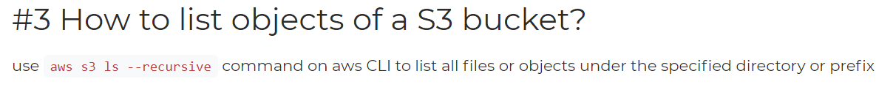

### Explain process of mounting s3 to ec2 instance:

#### 1. Update the system

apt-get update

#### 2. Install the dependencies

sudo apt-get install automake autotools-dev fuse g++ git libcurl4-gnutls-dev libfuse-dev libssl-dev libxml2-dev make pkg-config

#### 3. Clone s3fs source code from git

git clone https://github.com/s3fs-fuse/s3fs-fuse.git

#### 4. Run below commands to change source code directory, compile and install the code.

cd s3fs-fuse

./autogen.sh

./configure --prefix=/usr --with-openssl

make

sudo make install

#### 5. Run s3fs command to check where command is placed

which s3fs

#### 6. Get your access key and secret key ready.

#### 7. Create a new file in /etc with the name passwd-s3fs and paste your access key and secret key.

touch /etc/passwd-s3fs

vim /etc/passwd-s3fs

Your_accesskey:Your_secretkey

#### 8. Change the permission of the file

sudo chmod 640 /etc/passwd-s3fs

#### Now create a directory or provide the path of an existing directory and mount S3bucket in it.

mkdir /mys3bucket

s3fs your_bucketname -o use_cache=/tmp -o allow_other -o uid=1001 -o mp_umask=002 -o multireq_max=5 /mys3bucket

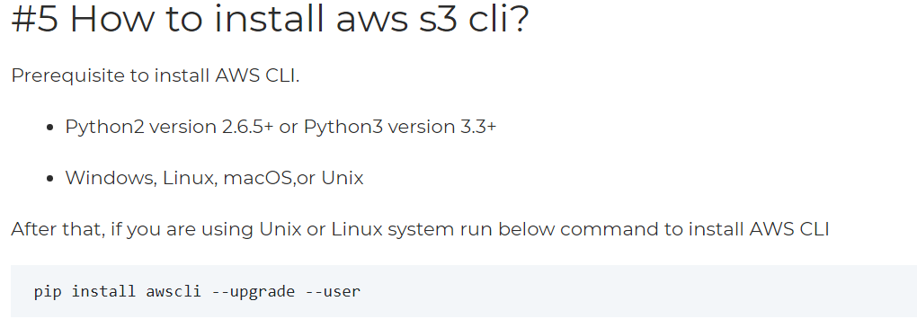

### How is buffer used in AWS?

It is used to make the system more robust and manage traffic by synchronizing different components. The component processes the requests in an imbalanced way. Using buffer, the components work at the same speed for faster services and will also be balanced.